WEEK 6 – Privileges Escalating Testing

Objective:
This week I tried to do privilege escalation testing to check if the end user can increase their privileges and become an admin by forging the JWT token. The tools used for this test are Postman to access the protected admin endpoint and JSON Web Token (JWT) Debugger, which is used to forge the token.

Previous findings

- Week 3 finding
During week 3, I tested the token behavior after the user logs out. I logged in as an admin and received a valid access token, then logged out and tried to reuse the same token again. The said token was rejected, which shows that it can not be used to get admin privileges.

- Week 4 finding
During week 4, I tested the registration endpoint to see if it can be used by low-level users such as end users or analysts. The test showed that only admin is authorized to register new users. Therefore, using the register endpoint is unsubtle for privilege escalation.

Week 6 test method:
For this test, using the knowledge gained from previous weeks, I tested if an end user can increase their privileges by changing the role inside the JWT token from end user to admin.
First, I obtain the access when I log in as an end user successfully. Using the token with an online tool such as JSON Web Token (JWT) Debugger allows me to change the role inside the token from end user to admin.
Then, the new Forge token was tested on the api/users/user endpoint, which is an admin-protected page.
There are two outcomes to this test.
- forge a token with no JWT secret
This test returned 401 Unauthorized with the message “invalid token.” This is because the forged token was created without the correct JWT secret. Therefore, the system did not accept the request without it.

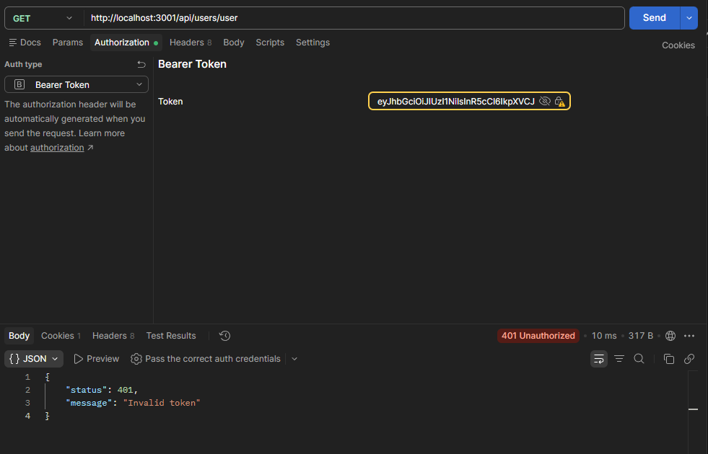
Figure 1 shows output when using the forage token with no valid secret key.

- Forge a token with the correct JWT secret
The test returned 401 Unauthorized with the message “logged out.” This is because when the request was made, the forge token was compared to the actual access token stored for the user in the database. Therefore, even when the role was changed to admin with the correct secret key, the system did not allow access to the admin endpoint.

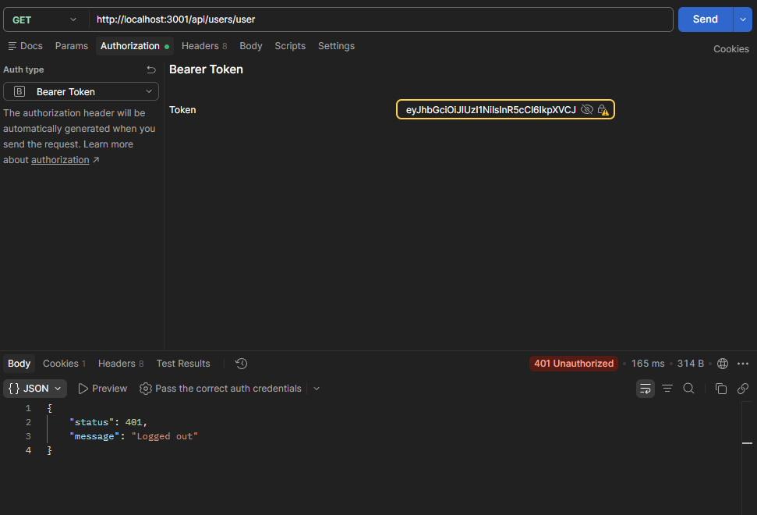
Figure 2 shows output when using the forage token with valid secret key.

Finding:
The system design does not allow low-level users to increase their privileges and gain higher access. The different production layers prevent the user from changing their role or accessing protected pages that they are not allowed to use.

JWT token validation flow:
This flow diagram shows how the system checks the JWT token before allowing access. First, it checks if the token has a valid JWT secret. Then, the system checks if the token matches the one that is stored in the database. This design helps prevent privileges from escalating from low-level users to higher levels.
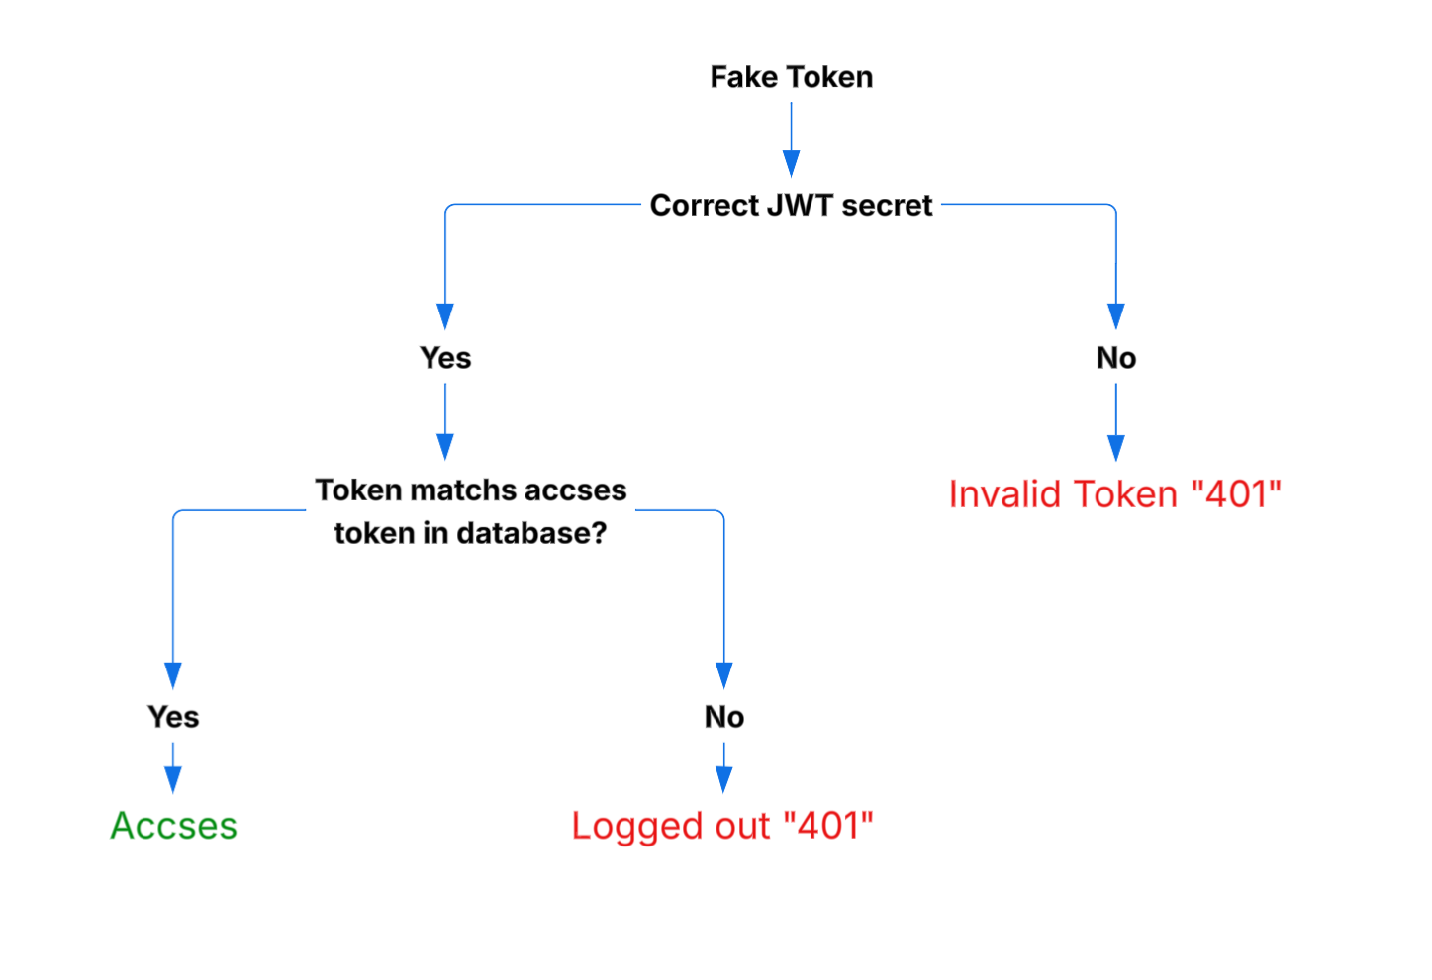
Figure 3 shows JWT token validation flow

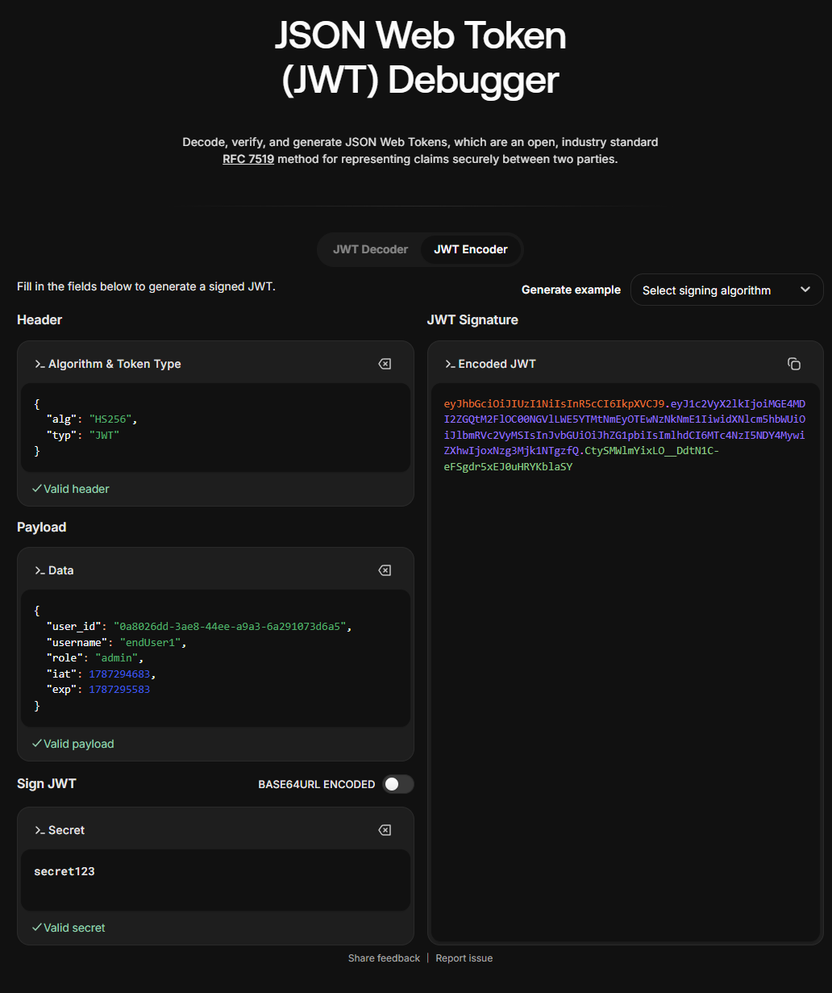
Figure 4 shows the process of forging a JWT token.

